**FDA Lab-6**

1. WAP in R to print the given pattern and take n from the user

|  |  |  |  |  |  |  |
| --- | --- | --- | --- | --- | --- | --- |
| 1 |  |  |  |  |  |  |
| 2 | * | 3 |  |  |  |  |
| 4 | * | 5 | * | 6 |  |  |
| 7 | * | 8 | * | 9 | * | 10 |

1. WAP in R to find the **sum ( )** of the series 1/1! + 2/2! + 3/3! + ..N/N!. Use method user defined method for **factorial ( )**. (function calling with in function)
2. Convert the **data frame1 to data frame2** as given format

Create groupings or categories for infant, children, young, adults and elderly as given below

0 to 2 = ‘Toddler/Baby’

3 to 17 = ‘Child’

19 to 40 = ‘Young’

41 to 65 = ‘Adult’

66 to 99=’Elderly’

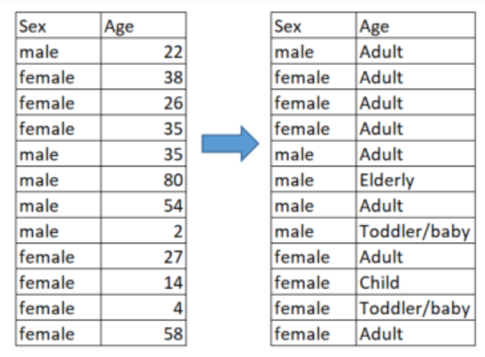

**4.**Create a Data frame as given below as D1

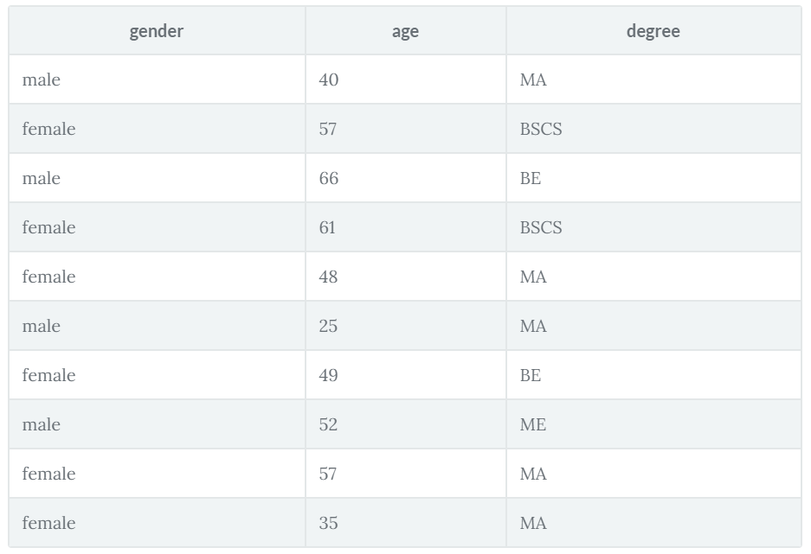

1. Sort the data frame D1 in the ascending order by using **order ()** based on the variable age and save as D2.
2. Create data frame D3 from D2 where age is below 50.
3. Again sort D3 ascending order by using **order ()** based on the variable **Gender** and save as D4.
4. Display only the female having MA degree from D4.